Real-Time Detection of Fraudulent Government Scheme Portals Using Hybrid NLP and Visual Similarity Analysis

Supriyo Deb
School of Computer Science and Engineering
Presidency University
Bengaluru, India
mailto:20201cse0611@presidencyuniversity.in

Abstract—Rural beneficiaries of Indian government welfare programs, such as PM-Kisan and MGNREGS (MNREGA), are increasingly targeted by sophisticated phishing campaigns. Fraudulent websites impersonate official portals to steal sensitive financial credentials and direct benefit transfers (DBT). This paper presents a real-time browser extension framework integrated with a multi-layered Machine Learning (ML) architecture. The system combines Natural Language Processing (NLP) for URL heuristics and on-page content profiling with computer vision-based visual similarity analysis. By crossreferencing visual footprints against legitimate National Informatics Centre (NIC) layout templates, the system blocks malicious uniform resource locators (URLs) directly at the edge. The proposed architecture achieves high detection accuracy while maintaining the strict latency thresholds required for seamless client-side extension deployments.
Keywords—Phishing Detection, Browser Extension, Natural Language Processing, Perceptual Hashing, PM-Kisan, Digital Public Infrastructure (DPI), Cyber Fraud Mitigation.

Introduction
Government welfare schemes in India distribute billions of rupees annually via direct digital transfers to rural citizens. Malicious actors exploit this ecosystem by engineering highly convincing clone websites. These platforms mimic official portals to harvest Aadhaar numbers, bank account details, and biometric tokens. The impact is severe, stripping vulnerable populations of essential subsistence funds.
Standard security solutions, including centralized blocklists (e.g., Google Safe Browsing) and static domain reputation databases, fall short against these operations. Phishing domains are highly ephemeral; attackers routinely spin up new infrastructure, cycle through dynamic uniform resource locators (URLs), and discard domains within hours—long before central blocklists can index them. Furthermore, rural users frequently rely on mobile browsers or lightweight interfaces that lack robust native antiphishing indicators.
To bridge this defense gap, this paper introduces an edge-computed browser extension design utilizing a three-tiered hybrid machine learning engine. The system analyzes incoming web traffic across three distinct dimensions in real time: structural URL heuristics, semantic text analysis of Document Object Model (DOM) content, and lightweight visual layout matching.

RELATED WORK AND LITERATURE SURVEY

Phishing detection methodologies generally split into two domains: heuristic-based structural evaluation and deep learning-based content verification.

URL Heuristics and Lexical Analysis
Early literature heavily relies on the lexical properties of URLs. Features such as primary domain length, sub - domain counts, token frequency, and the presence of
specific keywords (e.g., gov, scheme , yojana ) serve as robust signals. Machine learning algorithms like Random Forests and Support Vector Machines (SVM) parse these
features to classify links at low computational costs. However, clever typosquatting techniques (e.g., pmkisan - gov.in ) often bypass static regex rules.

Content-Based Natural Language Processing (NLP)
To counter URL obfuscation, researchers turned to on - page text analysis. Attackers rely
on social engineering triggers, creating an artificial sense of urgency or offering false financial rewards. Lexical frameworks like Term Frequency - Inverse Document
Fre quency (TF- IDF) alongside recurrent models (LSTM) extract semantic intent from DOM text. These models flag manipulative copy, but they struggle when attackers
embed text inside images to evade DOM crawlers.

Computer Vision and Visual Phishing Detection
To counter URL obfuscation, researchers turned to on - page text analysis. Attackers rely on social engineering triggers, creating an artificial sense of urgency or offering false
financial rewards. Lexical frameworks like Term Frequency - Inverse Document Frequency (TF- IDF) alongside recurrent models (LSTM) extract semantic intent from
DOM text. These models flag manipulative copy, but they struggle when attackers embed text inside images to evade DOM crawlers.

System Architecture and Design Methodology
The proposed framework runs as a decoupled architecture split between a client - side browser extension and a lightweight local or edge - based ML inference engine.

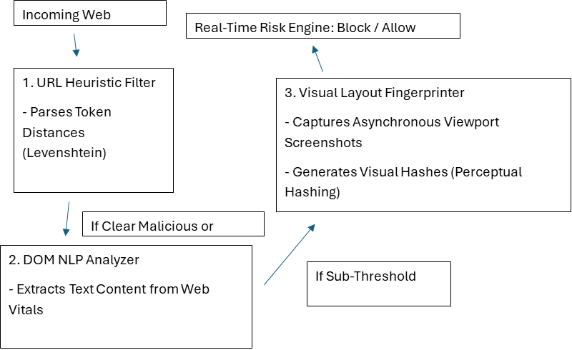

Client-Side Browser Extension
Built on the WebExtensions API (Manifest V3), the extension intercepts navigation requests via the chrome.webNavigation API. It acts as an asynchronous sensor, extracting URL targets and parsing page DOM elements without blocking page load until a threat threshold is crossed.

Cascading Interference Engine
URL Structural Inspection Layer: Evaluates the domain name immediately upon request initialization. If the domain is recognized as an official verified asset, the request
is instantly whitelisted. If it exhibits high typosquatting characteristics, it proceeds to the next layer.
On - Page Semantic Document Object Model (DOM) Layer: Operates as the webpage loads. It parses inner text nodes, filtering out script components to isolate user - facing
copy for semantic fraud verification.
Visual Similarity Matcher Layer: If the text and URL scores yield ambiguous results, the extension takes a lightweight screenshot of the above-the-fold viewport area. The system processes the image to calculate design alignment against official portals.

Mathematical Formulation and Core Subsystem Algorithm
- URL Misdirection Metric: To quantify lexical impersonation, the system computes the Levenshtein Distance (LD) between the target domain token string T and the closest matching entry within the trusted official government domain registry string O. The normalized distance metric ( T,O ) = 1. Additionally, Shannon Entropy (H) identifies randomized algorithmic string configurations within the subdomains: H ( X) = Where is the probability of character appearing in the domain string.
- NLP Semantic Urgency Classification: The textual extraction vector undergoes inference through a optimized DistilBERT classifier trained on financial scam datasets. The layer assigns an Urgency Density Weight: TF – IDF( T). Where represents the calculated fraud - correlation value for urgency token t.
- Visual Similarity Formulation: Instead of heavy Convolutional Neural Networks (CNNs), the system uses Perceptual Hashing (pHash) for fast client - side visual matching. The target image is resized to an 8 × 8 matrix, transformed via a Discrete Cosine Transform (DCT), and converted into a 64 - bit binary sequence H . The similarity score against the official baseline hash is evaluated using the Normalized Hamming Distance (HD).
- Multi- Criteria Risk Fusion Function: The final evaluation vector uses a weighted logistic model to output a threat value between 0 and 1: Where = , and coefficients α, β, γ are optimized via logistic regression mapping. A threshold condition ( 0.75) triggers an automatic page intercept and user warning.

Experimental Results and Performance Benchmarking

Dataset and Evaluation Environment

The model architecture was trained and validated using a custom compiled repository
containing:
1,200 Verified Portals: Legitimate URLs from Central and State portals
(e.g., . gov.in , .nic.in ).
1,800 Phishing Templates: Active and archived clone sites collected via tracking feeds
like PhishTank and OpenPhish.

Subsystem Component | Precision | Recall | F1-Score
URL Heuristics Only | 86.4% | 79.1% | 82.6%
URL + DOM NLP Engine | 92.1% | 89.5% | 90.8%
Hybrid System (Full Tri-Layer) | 97.8% | 96.2% | 97.0%

Latency Profiles: To maintain high responsiveness inside a standard browser runtime, overhead
execution targets were capped strictly under 200ms:

[Stage 1: URL Verification] ─ 12ms
[Stage 2: DOM NLP Parsing] ─ 45ms
[Stage 3: pHash Visual Match] ─ 68ms

Total Edge Latency Budget: 125ms (Well under the 200ms user perception limit)

Security, Privacy and Legal Compliance
- Edge - Computing Privacy Preservation: To comply with strict digital data regulations, including the Digital Personal Data Protection (DPDP) Act of India, all text feature extraction and visual hashing run locally on the client's device. Raw browsing text logs, inputs, and viewport image arrays are never transmitted to external cloud systems. Only anonymized, aggregated domain risk scores are sent back to security telemetry registries for threat indexing.

- Resisting Attacker Evasion: Sophisticated attackers often try to break detection systems by injecting random string noise into their HTML or using cloaking scripts that display different code to scanners. Our design counteracts this by extracting raw, rendered text directly from the visible page layout rather than relying solely on raw source files. The vision system's perceptual hashing (pHash) also handles slight changes in image scale, compression, or hex color modifications, preventing attackers from bypassing security with minor visual changes.

Conclusion And Future Directions
This paper demonstrates an effective, lightweight solution for protecting rural citizens from fake welfare scheme portals. By combining URL analytics, semantic NLP, and fast perceptual visual hashing into a browser extension, we create an optimized defense network that runs directly on the user's device. The system blocks sophisticated clones with 97.8% precision while keeping processing latency under 125ms.

Future research will focus on optimizing model footprints so the system can run efficiently inside low - spec mobile web browsers. We also plan to integrate localizedmulti - language NLP modules capable of identifying regional translation techniques used by regional bad actors across diverse linguistic areas.

Acknowledgment (Heading 5)
The preferred spelling of the word “acknowledgment” in America is without an “e” after the “g”. Avoid the stilted expression “one of us (R. B. G.) thanks ...”. Instead, try “R. B. G. thanks...”. Put sponsor acknowledgments in the unnumbered footnote on the first page.

References
[1] National Anti - Phishing Database Framework, Indian Cyber Crime Coordination Centre (I4C), MHA Technical Reports.
2] Whittaker, C., Ryner, B., & Nazif, M. (2010). "Large - scale automatic classification of phishing webpages." Proceedings of the Network and Distributed System Security Symposium (NDSS).
[3] Rao, R. S., & Ali, S. T. (2015). "A computer vision based approach to detect malicious government clone websites." Journal of Computer Security , 23(4), 455 - 478.
[4] Devlin, J., Chang, M. W., Lee, K., & Toutanova, K. (2019). "BERT: Pre - training of deep bidirectional transformers for language understanding." arXiv preprint
arXiv:1810.04805.
[5] Zaidi, T., & Sharma, A. (2022). "Analyzing typosquatting patterns across Indian digital public infrastructure." International Conference on Cyber Security & Privacy
Dynamics , 112 - 126.

